**MY LAB SERVICES for release 1.0**

The below services are for the initial WebApp release. Services will be added / removed based on demand. Services which have been classed as “**confirmed**” can be added to the webapp with immediate effect; those services “**unconfirmed**” are still being finalised (in terms of pricing, packages, etc).

“**Packages and Prices**” will describe the services and quote the end user based on their selection. Not all Prices below are final and may need to be adjusted later. The website should allow me to block dates and time slots, as well as adjust prices and descriptions.

All purchased services are delivered to the end user, in the same way as Uber(eats), Deliveroo, Laundrapp, etc

The App will only provide services within London, UK locations, therefore postcodes which will be included / excluded will have to be discussed and confirmed prior to launch. **Update**: A list of postcodes have been sent over already.

We have video footage and images that you can use visualise the packages / services, but will be providing more closer to launch - however you may add relevant images for the time being as fillers. Please note for each service there will be a descriptions which we will provide once design has been completed for the WebApp.

**Category descriptions:**

Book a range of services to your doorstep:

**Car Lab:**

Car Wash, Alloy Refurbishment & Callipers Colour Change, Bodywork / Smart Repair, Coding, Remaps & MORE

**Shoe Lab:**

Cleaning, Restoration & Customisation

**Clothing Lab:**

Dry Cleaning, Laundry, Ironing, Repairs & Alterations

**Electronics Lab:**

Refurbishment & Repairs

**CarLab**

|  |  |
| --- | --- |
| **Services** | **Confirmed / Unconfirmed** |
| Car Wash / Valet | CONFIRMED |
| Tinting | UNCONFIRMED |
| Wheel Refurbishment / Colour Change | CONFIRMED |
| Calliper Respray / Colour Change | CONFIRMED |
| Coding / Diagnostics | CONFIRMED |
| Remaps | CONFIRMED |
| Tracker | UNCONFIRMED |
| Dash Cam | UNCONFIRMED |
| Bodywork / Smart Repair | CONFIRMED |

**PACKAGES AND PRICES**

Car Wash / Valet

**Packages:**

The Valet packages we currently offer are **Mini**, **Full** and **Super**.

The singular services we offer are “**Premium** **Interior Clean**” and “**Premium** **Exterior Wash**”

**Service + Pricing:**

|  |  |  |  |  |
| --- | --- | --- | --- | --- |
| **Package** | **Interior** | **Exterior** | **Vehicle Size** | **Price** |
| **Mini Valet**  (Maintenance in & Out Clean)  **Time: 60mins** | * Rubbish Removed * Door Shuts Cleaned * All Interior Surfaces Wiped * Carpet, Floor Mats & Seats Vacuumed * Seats Wiped Down * Windows Cleaned & Polished | * Wash & Buff * Alloys Cleaned * Tyre Shine Applied * Windows Cleaned & Polished | **Small** (Hatchbacks)  e.g VW Golf | **£30** |
| **Medium** (Coupes, Convertibles & Saloons)  e.g BMW 5 Series | **£35** |
| **Large** (Estates, SUVs & MPVs) e.g Audi Q5 | **£40** |
| **Mini Valet Plus**  (Get a Showroom Finish)  **Time: 60-90mins** | * Rubbish Removed * Door Shuts Cleaned * Carpet, Floor Mats & Seats Vacuumed * Windows Cleaned & Polished * All Interior Surfaces Cleaned * All Interior Surfaces Dressed * Seats Wiped Down * Interior Air Freshened & Deodorised | * Wash & Buff * Alloys Cleaned * Tyre Shine Applied * Alloy Sealant Applied * Windows Cleaned & Polished * Plastics Dressed * Wax Polish | **Small** (Hatchbacks)  e.g VW Golf | **£45** |
| **Medium** (Coupes, Convertibles & Saloons)  e.g BMW 5 Series | **£55** |
| **Large** (Estates, SUVs & MPVs) e.g Audi Q5 | **£65** |
| **Super Valet**  **(Recommended For Super Dirty Cars)**  **Time: 90+mins** | * Rubbish Removed * Door Shuts Cleaned * Carpet, Floor Mats & Seats Vacuumed * Windows Cleaned & Polished * All Interior Surfaces Cleaned & Dressed * Pedals Cleaned * Carpet and Floor mats Deep Cleaned & Protected * Fabric / Leather Seats Deep Cleaned & Protected * Interior Air Freshened & Deodorised | * Snow Foam Pre-Wash * Wash & Buff * Alloys Cleaned * Tyre Shine Applied * Alloy Sealant Applied * Windows Cleaned & Polished * Ultra HD Wax Polish | **Small** (Hatchbacks)  e.g VW Golf, BMW 1 Series | **£80** |
| **Medium** (Coupes, Convertibles & Saloons)  e.g BMW 5 Series, Mercedes CLA | **£95** |
| **Large** (Estates, SUVs & MPVs) e.g Audi Q3, BMW X5 | **£110** |
| **Premium Interior Clean** | * Rubbish Removed * Carpet, Floor Mats & Seats Vacuumed * All Interior Surfaces Cleaned * All Interior Surfaces Dressed * Door Shuts Cleaned * Windows Cleaned & Polished | X | **Small** (Hatchbacks)  e.g VW Golf, BMW 1 Series | **£18** |
| **Medium** (Coupes, Convertibles & Saloons)  e.g BMW 5 Series, Mercedes CLA | **£20** |
| **Large** (Estates, SUVs & MPVs) e.g Audi Q3, BMW X5 | **£22** |
| **Premium Exterior Wash** | X | * Wash & Buff * Alloys Cleaned * Tyre Shine Applied * Windows Cleaned & Polished * Wax Polish | **Small** (Hatchbacks)  e.g VW Golf, BMW 1 Series | **£18** |
| **Medium** (Coupes, Convertibles & Saloons)  e.g BMW 5 Series, Mercedes CLA | **£20** |
| **Large** (Estates, SUVs & MPVs) e.g Audi Q3, BMW X5 | **£22** |

**ADD ONS**

**Users can tick any of the below option to add to their booking:**

Pet Hair Removal (Interior): **£10**

Mould Removal (Interior): **£15**

Sanitisation Service (Interior): **£40 (subject to availability)**

Pedals Cleaned (Interior): **£5**

**Congestion Zone Surcharge £15**

Some users may live within the congestion charge zone in London; this will require an additional payment of £15 which the user must agree to. They must tick “yes” to the question **“Do you live in the congestion charge zone?”**

**Operational Hours / Days: Monday-Sunday**, **8am-6pm** (this may vary depending on season)

**Booking Time Slots:** **8am-10am, 10am-12pm, 12pm-2pm, 2pm-4pm, 4pm-6pm**

**Note:** These are the times at which the Valeter will arrive between. If a time slot has been booked by a user, then it should appear unavailable to another user for the remainder of that day. Same day bookings will automatically incur an extra £5 surcharge “.

**Process**

1. Select Service (i.e. Car Wash)
2. Select Car Size (i.e. Medium)
3. Select Package (i.e. Mini Valet)
4. Select Date (i.e. 02/03/21)
5. Select Time Slot (i.e. 4pm-6pm)
6. Enter vehicle Info & address (the user can save this information for future bookings or use previously saved information)
7. Add to basket
8. At this point the user can go to checkout and make payment, or the app can prompt the user to explore the app to add another service to the basket.

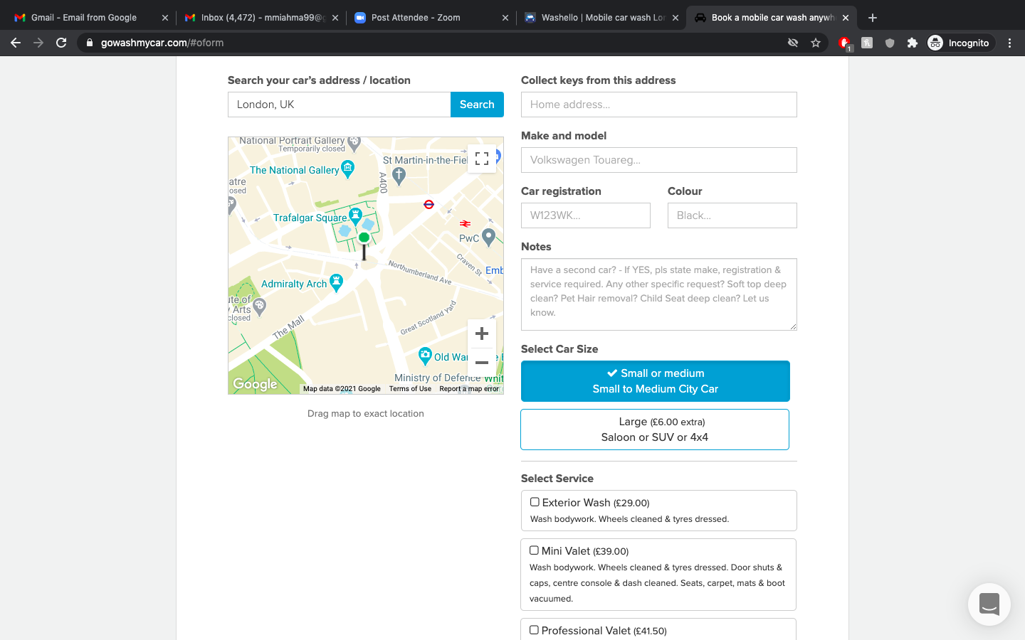Example

Source: <https://www.gowashmycar.com/#oform>

Alloy Refurbishment / Colour Change

Duration: 4-5 Hours Per Set of 4

|  |  |  |  |  |
| --- | --- | --- | --- | --- |
| **Wheel Size (Inches)** | **Individual Alloy Price** | | **All 4 Alloys**  **Set Price** | |
| 15’’-18’’ | £70 | | £250 | |
| 19”-22” | £80 | | £300 | |
| **Special Offer** | | **Price** | |
| Alloy Refurbishment (set of 4) + 4 Callipers  15’’-18’’ | | £330 | |
| Alloy Refurbishment (set of 4) + 4 Callipers  19”-22” | | £380 | |
| Alloy Refurbishment (set of 4) + 4 Callipers with Decal  15’’-18’’ | | £350 | |
| Alloy Refurbishment (set of 4) + 4 Callipers with Decal  19”-22” | | £400 | |

**Alloy Colours: Gloss Black (POPULAR), Matt Black, Silver, Gun Metal.** Other colours can be requested by contacting support.

**Operational Hours / Days: Monday-Sunday**, **8am-6pm** (this may vary depending on season)

**Booking Time Slots / Days**

**Operational Days / Hours: Monday-Sunday**, **8am-6pm** (this may vary depending on season)

**Booking Time Slots:** **8am-10am, 10am-12pm, 12pm-2pm, 2pm-4pm, 4pm-6pm**

**Note:** These are the times at which the **Customizer** will arrive between. The app should automatically present the 1st week on the calendar as fully booked by default and only show availability the next week onwards. If a time slot has been booked by another user, then it should appear unavailable to the user for the remainder of that day (basically there is 1 quantity per time slot). If this isn’t possible to do automatically then give me

**Process**

1. Select Service (i.e. Alloy Refurbishment)
2. Select Wheel Size (i.e.18 inch)
3. Select Number of Wheels (i.e. Set of 4)
4. Select Colour (i.e. Gloss Black)
5. Select Date (i.e. 02/11/20)
6. Select Time Slot (i.e. 4pm-6pm)
7. Enter vehicle Info & address (the user can select saved information from previous bookings)
8. Add to basket
9. At this point the user can go to checkout and make payment, or the app can prompt the user to explore the app to add another service to the basket.

Calliper Respray

**Duration: 2 Hours Per Set of 4**

|  |  |
| --- | --- |
| **Options** | **Callipers**  **Set Price (All 4)** |
| Callipers | £120 |
| Callipers with Decal | £140 |
| **Special Offer** | **Price** |
| Alloy Refurbishment (set of 4) + 4 Callipers  15’’-18’’ | £330 |
| Alloy Refurbishment (set of 4) + 4 Callipers  19”-22” | £380 |
| Alloy Refurbishment (set of 4) + 4 Callipers with Logo  15’’-18’’ | £350 |
| Alloy Refurbishment (set of 4) + 4 Callipers with Logo  19”-22” | £400 |

**Colours: Red, Orange, Yellow, Green, Blue, Lime, Purple, Brown, Magenta, Cyan, Navy, Turquoise, Silver, Black, White**

**Decals:** S-line, Audi S, AMG, BMW M

**Booking Time Slots / Days**

**Operational Days / Hours: Monday-Sunday**, **8am-6pm** (this may vary depending on season)

**Booking Time Slots:** **8am-10am, 10am-12pm, 12pm-2pm, 2pm-4pm, 4pm-6pm**

**Note:** These are the times at which the **Customizer** will arrive between. The app should automatically present the 1st week on the calendar as fully booked by default and only show availability the next week onwards. If a time slot has been booked by another user, then it should appear unavailable to the user for the remainder of that day (basically there is 1 quantity per time slot).

**Process**

1. Select Service (i.e. Calliper Respray)
2. Select Package (i.e Calliper + Decal)
3. Select Colour (i.e. Red)
4. Select Decal (i.e AMG)
5. Select Date (i.e. 02/11/20)
6. Select Time Slot (i.e. 4pm-6pm)
7. Enter vehicle Info & address (the user can select saved information from previous bookings)
8. Add to basket
9. At this point the user can go to checkout and make payment, or the app can prompt the user to explore the app to add another service to the basket.

**Example site / process:**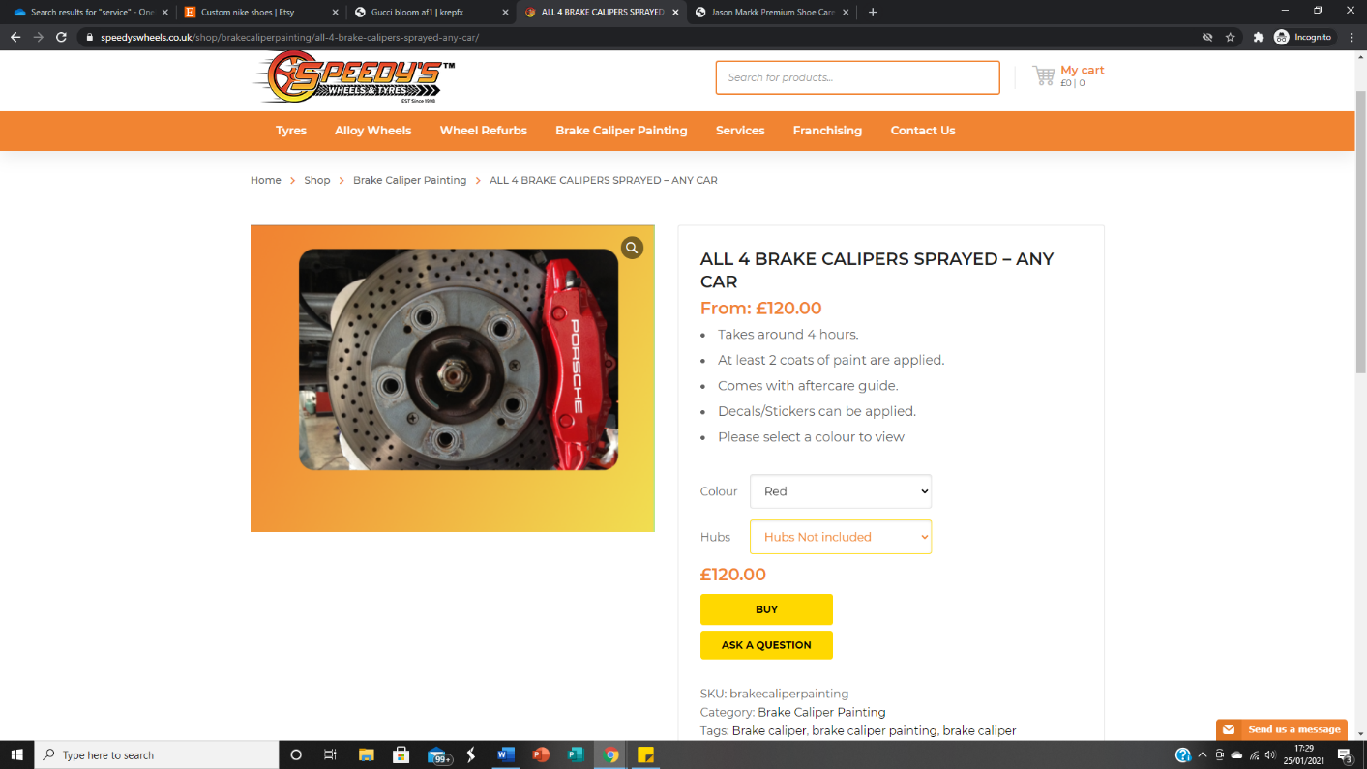

**Source: https://speedyswheels.co.uk/shop/brakecaliperpainting/all-4-brake-calipers-sprayed-any-car/**

**ShoeLab**

|  |  |
| --- | --- |
| **Services** | **Confirmed / Unconfirmed** |
| Custom Shoes | CONFIRMED |
| Shoe Cleaning & Restoration | CONFIRMED |

Custom Shoes

**Shipping Time:**

14-21 Days – FREE DELIVERY

**Deliver Upgrades:**

10 Days FAST TRACK - £10

7 Days VIP - £15

**Air Force 1s Customs**

**Colours:** Black / White

**Shoe Style:** Low / Mid

**(show users the sizes in a dropdown list)**

|  |  |  |
| --- | --- | --- |
| **Design** | **Sizes (uk)** | **Price** |
| **Louis Vuitton** | **3 – 5.5**  **6 - 17** | **£110**  **£140** |
| **Post Code** | **3 – 5.5**  **6 - 17** | **£95**  **£125** |
| **Naruto Tick** | **3 – 5.5**  **6 - 17** | **£105**  **£135** |
| **Dior** | **3 – 5.5**  **6 - 17** | **£125**  **£155** |
| **Gucci Bloom** | **3 – 5.5**  **6 - 17** | **£115**  **£165** |
| **Custom Design** | **Any** | **Quote Form** |

**Note: These designs and type of shoe will update monthly**

**Process**

1. Select Service (i.e. Custom Shoes)
2. Select Design (i.e Dior)
3. Select Shoe Colour Colour (i.e White)
4. Select Shoe Type (i.e Low)
5. Select Shoe Size (i.e 9 UK)
6. Select Delivery Service (i.e VIP)
7. Enter shipping address (the user can select saved information from previous bookings)
8. Add to basket
9. At this point the user can go to checkout and make payment, or the app can prompt the user to explore the app to add another service to the basket.

Example Shoes

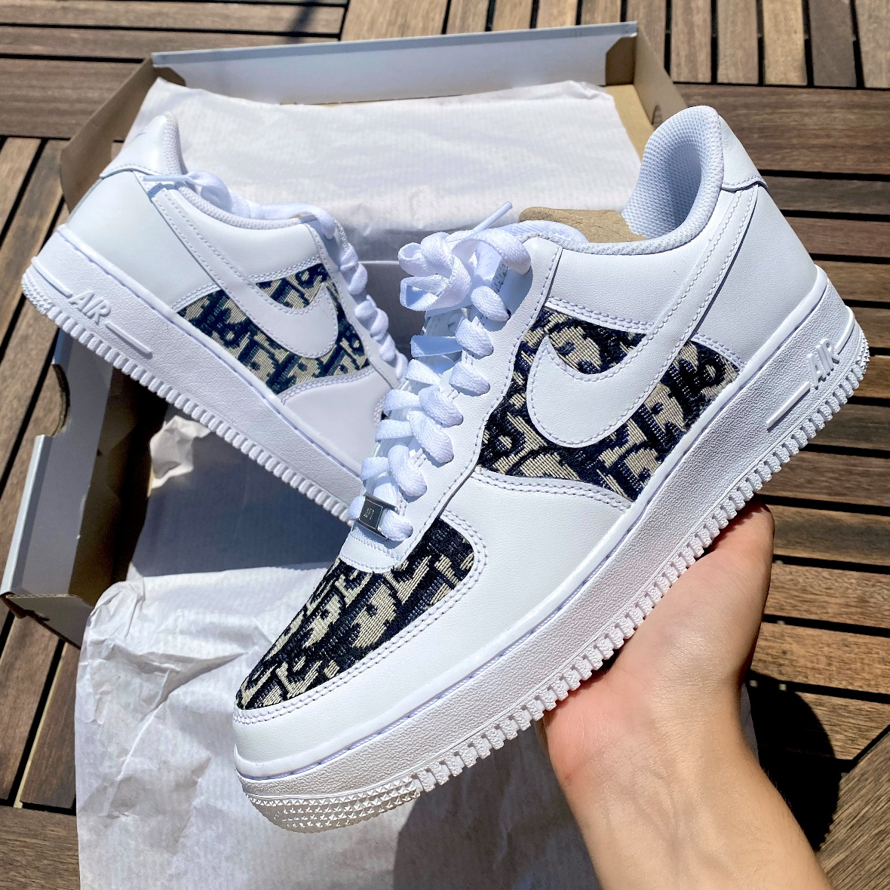

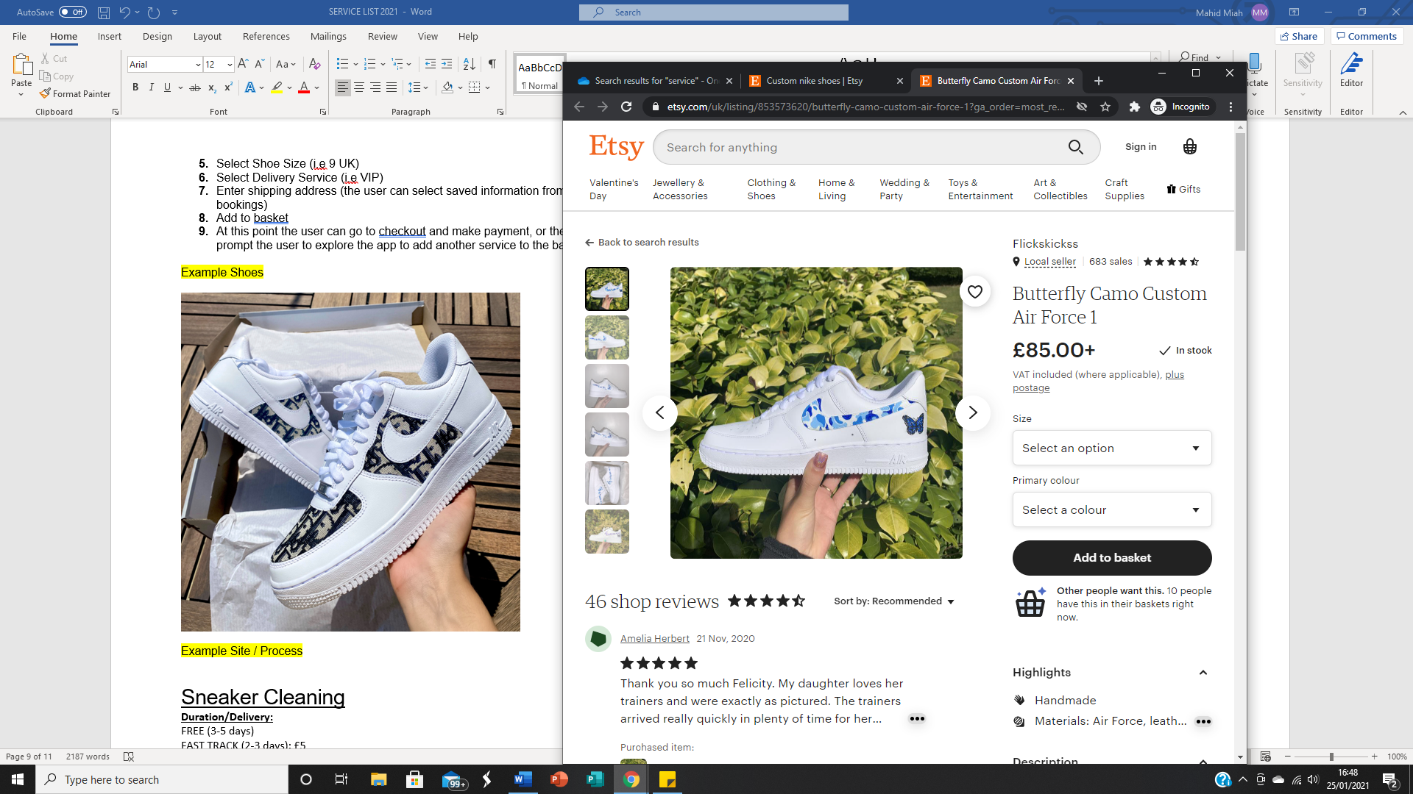Example Site / Process

Source: https://www.etsy.com/uk/listing/853573620/butterfly-camo-custom-air-force-1?ga_order=most_relevant&ga_search_type=all&ga_view_type=gallery&ga_search_query=custom+nike+shoes&ref=sr_gallery-1-31&col=1

Sneaker Cleaning

**Duration/Delivery:**

FREE (3-5 days)

FAST TRACK (2-3 days): £5

VIP (Next Day): £10

VVIP (Same Day): £20

|  |  |
| --- | --- |
| STANDARD | £25 |
| PREMIUM (for designer shoes) | £35 |
| Restorations | Quote Form + Picture Attachment |

**Add Ons**

Water & Stain Protection: £1.49

Odour Treatment £1.49

Shoe Shapers: £3.49

**Process**

1. Select Service (i.e. Sneaker Clean)
2. Select Package (Standard)
3. Select Delivery Service (i.e VIP)
4. Select Date (i.e. 02/11/20)
5. Select Pick Up Time Slot (i.e. 4pm-7pm)
6. Enter shipping address (the user can select saved information from previous bookings)
7. Add to basket
8. At this point the user can go to checkout and make payment, or the app can prompt the user to explore the app to add another service to the basket.

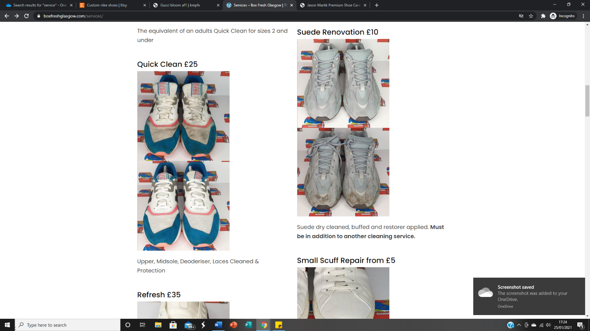Example Services

**Source:** <https://www.boxfreshglasgow.com/services/>

**ClothingLab**

|  |  |
| --- | --- |
| **Services** | **Confirmed / Unconfirmed** |
| Dry Cleaning | CONFIRMED |
| Ironing | CONFIRMED |
| Repairs | CONFIRMED |
| Laundry | CONFIRMED |

**Our partners @** [**https://1stopwash.com/**](https://1stopwash.com/) **will be carrying out this service so all services can be copied from their website – except for trainer service.**

*We pick up & deliver everyday between 4-7pm & 7-10 pm.*

**Process (The same as Laundrapp.com)**

1. Select Service (i.e. Dry cleaning)
2. Select Item(s) (i.e Suit, trousers, etc)
3. Select Date (i.e. 02/11/20)
4. Select Pick Up Time Slot (i.e. 4pm-7pm)
5. Select Drop Off Time Slot (i.e. 7pm-10pm)
6. Enter Delivery Address (the user can save this information for future bookings or use previously saved information)
7. Add to basket
8. At this point the user can go to checkout and make payment, or the app can prompt the user to explore the app to add another service to the basket.

**ElectronicsLab**

I will send this separately but please refer to: https://www.ismash.com/

**Further Notes:**

I will be sending a revised version of this document to include more details such as: service descriptions, terms, updated prices, etc.

The App should send notifications of offers / reminders

For new users, upon opening the app the first page they are greeted with should display a welcome message and the logo. The user can press continue to go through a walkthrough of the app and its features. Or they can skip. At the end of the walkthrough, the app will ask for the users’ postcode to see if services can be provided in that area – on this page the user can also sign in or register. If we are unable to cater to their desired location, the app should suggest they sign up to the mail box to be notified of updated service area coverage. However, they are still able to browse the different services but unable to add to basket and proceed to checkout.